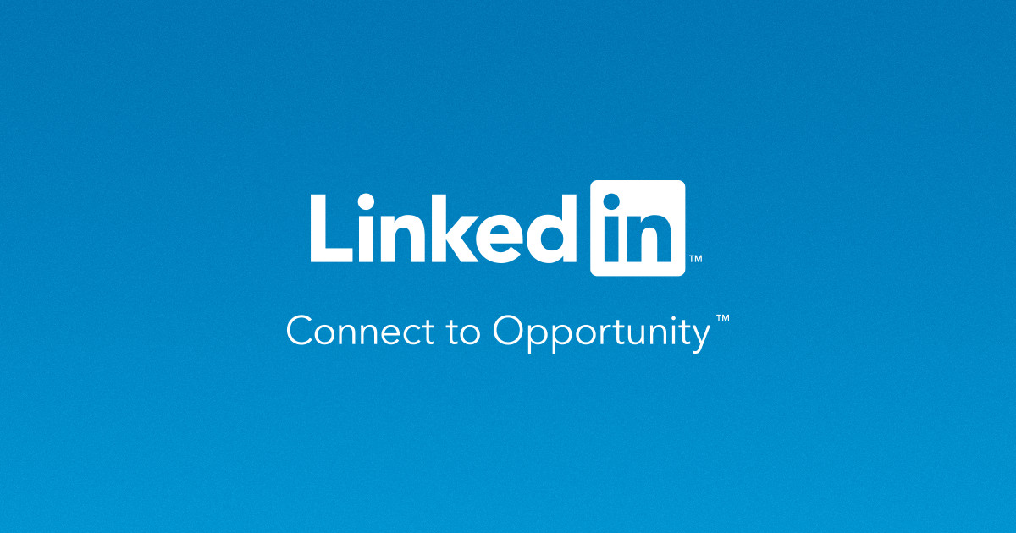

**Product Dissection for LinkedIn**

**Doc link:** [**https://docs.google.com/document/d/12n89gnxENkH6Y6w8Rval2_KYV6Jl3aggaavZbwq4s18/edit?usp=sharing**](https://docs.google.com/document/d/12n89gnxENkH6Y6w8Rval2_KYV6Jl3aggaavZbwq4s18/edit?usp=sharing)

**Video link:** [**https://drive.google.com/file/d/1mDzov6lYGMJ3SP_kDxHZujGnVkWfgC4q/view?usp=drive_link**](https://drive.google.com/file/d/1mDzov6lYGMJ3SP_kDxHZujGnVkWfgC4q/view?usp=drive_link)

### **Company Overview:**

LinkedIn, founded in 2002 by Reid Hoffman and launched in 2003, has become the world's largest professional network, transforming how professionals connect, engage, and advance their careers. Acquired by Microsoft in 2016, LinkedIn has evolved into a global platform, renowned for its professional networking, job search capabilities, and industry insights. With a commitment to empowering individuals and businesses, LinkedIn has grown to over 800 million members, making it an indispensable tool for professionals worldwide.

### **Product Dissection and Real-World Problems Solved by LinkedIn:**

LinkedIn, a leading professional networking platform, has played a pivotal role in addressing real-world challenges by providing innovative solutions through its comprehensive product offerings. With a primary focus on connecting professionals and facilitating career growth, LinkedIn has bridged the gap between the professional world and digital networking, enabling individuals to advance their careers and make meaningful connections.

LinkedIn's fundamental feature, user profiles, serves as a virtual resume, allowing individuals to showcase their professional experiences, skills, and achievements. This core functionality addresses the challenge of presenting one's professional identity in a digital age, providing a platform for users to authentically represent themselves and make a strong impression on potential employers, clients, and collaborators.

LinkedIn's innovative tools for networking, such as "Connections" and "Recommendations," have transformed how professionals interact and build relationships. The "Recommendations" feature further solves the problem of building credibility in a virtual setting by allowing others to vouch for a user's skills and expertise, enhancing their professional reputation.

In conclusion, LinkedIn's product ecosystem effectively addresses real-world challenges by creating a platform that facilitates professional networking, career advancement, and talent acquisition. Through its diverse features and tools, LinkedIn empowers individuals and organizations to thrive in the digital professional landscape, offering practical solutions to the evolving needs of its global user base.

**Case Study: Real-World Problems and LinkedIn's Innovative Solutions**

LinkedIn, the world's premier professional networking platform, stands as a prime example of addressing substantial real-world challenges through innovative solutions. With a steadfast commitment to empowering professionals and facilitating career growth, LinkedIn has emerged as a transformative force bridging the gap between the professional realm and digital networking, facilitating career advancement, and fostering meaningful connections.

**Problem 1: Ineffective Professional Networking**

**Real-World Challenge:** In today's fast-paced business environment, professionals often struggle to build meaningful connections and expand their networks beyond traditional means. Traditional networking events and conferences are limited in reach and often do not provide the necessary tools for sustained professional growth.

**LinkedIn's Solution:** LinkedIn recognized the need for an online platform that enables effective professional networking. By creating user profiles that showcase work experience, skills, endorsements, and recommendations, LinkedIn provides a virtual space where professionals can connect, collaborate, and build relationships. The "Connect" feature allows users to expand their networks, making it easier to discover opportunities, share knowledge, and advance in their careers. LinkedIn effectively tackles the problem of ineffective professional networking by offering a digital hub for professional growth and connections.

#### 

**Problem 2: Job Search Challenges**

**Real-World Challenge:** Job seekers face various challenges, such as finding relevant job opportunities, researching potential employers, and standing out in a competitive job market.

**LinkedIn's Solution:**  LinkedIn addresses the challenges of job searching through its dedicated "Jobs" section. Users can search for jobs based on specific criteria, follow companies of interest, and even receive job recommendations tailored to their skills and career aspirations. Additionally, the "LinkedIn Learning" platform provides courses and certifications to help users acquire new skills and stay competitive in their fields. These solutions empower job seekers, making it easier for them to find and apply for relevant positions and develop professionally.

#### 

**Problem 3: Limited Personal Branding**

**Real-World Challenge:** Building a strong professional brand can be challenging, as traditional resumes and cover letters may not effectively showcase one's skills and personality.

**LinkedIn's Solution:** LinkedIn offers users the opportunity to create a comprehensive professional profile. This profile includes a profile picture, headline, summary, work experience, skills, endorsements, and recommendations. Users can also publish articles and share updates to demonstrate their expertise and personality, effectively solving the problem of limited personal branding on traditional job-seeking platforms.

**Problem 4: Skill Development and Learning**

**Real-World Challenge:** Professionals need continuous skill development to stay relevant in their industries, but finding accessible and high-quality learning resources can be a challenge.

**LinkedIn's Solution:** LinkedIn Learning, an integrated platform within LinkedIn, offers a vast library of courses on a wide range of topics. Users can access these courses to enhance their skills and knowledge, making it a one-stop solution for skill development and learning. This feature addresses the challenge of finding reliable and accessible resources for professional growth.

**Conclusion:**

LinkedIn's journey from a professional networking site to a global career development platform illustrates its ability to identify and solve real-world problems faced by professionals. By facilitating effective networking, simplifying job searching, enabling personal branding, and offering robust skill development opportunities, LinkedIn has become an indispensable tool for individuals seeking career growth and advancement. This case study demonstrates how LinkedIn's user-centric approach and continuous innovation have positioned it as a leader in the realm of professional networking and career development.

#### 

**Top Features of LinkedIn:**

1. **User Profiles:** LinkedIn allows users to create comprehensive professional profiles, showcasing their work experience, skills, endorsements, recommendations, and more.
2. **Network Building:** Users can connect with other professionals, colleagues, and industry peers to expand their professional networks.
3. **Jobs:** LinkedIn provides a dedicated job search feature, allowing users to search for and apply to job openings, as well as receive job recommendations.
4. **LinkedIn Learning:** Users can access a vast library of online courses and certifications to enhance their skills and knowledge.
5. **Personal Branding:** LinkedIn enables users to build and showcase their personal brands through profile customization, articles, and updates.
6. **Company Pages:** Companies can create profiles to showcase their culture, job openings, and industry insights.
7. **Groups:** Users can join professional groups to engage in discussions, share knowledge, and connect with like-minded individuals.
8. **Recommendations:** Users can give and receive recommendations to validate their skills and expertise.
9. **InMail:** A premium feature that allows users to send messages to other LinkedIn members, even if they are not connected.
10. **Premium Subscriptions:** LinkedIn offers premium subscriptions with additional features, such as enhanced visibility, job insights, and InMail credits.

### **Schema Description:**

LinkedIn's data model involves multiple entities that represent different aspects of the platform. These entities include Users, Connections, Jobs, Companies, Skills, Learning Courses, and more. Each entity has specific attributes that describe its properties and relationships with other entities.

**User Entity:**

* **UserID (Primary Key)**: A unique identifier for each user.
* **First_Name**: The user's first name.
* **Last_Name**: The user's last name.
* **Email**: The user's email address.
* **Headline**: A brief professional headline.
* **Summary**: A summary of the user's professional background.
* **Profile_Picture**: The user's profile picture URL.

**Connection Entity:**

* **ConnectionID (Primary Key)**: A unique identifier for each connection relationship.
* **UserID (Foreign Key referencing User Entity)**: The user who is connecting.
* **Connection_UserID (Foreign Key referencing User Entity)**: The user who is being connected to.

**Job Entity:**

* **JobID (Primary Key)**: A unique identifier for each job posting.
* **Company_Name**: The name of the hiring company.
* **Job_Title**: The title of the job position.
* **Job_Description**: Description of the job.
* **Location**: Location of the job.
* **Application_Link**: Link to apply for the job.

**Skill Entity:**

* **SkillID (Primary Key)**: A unique identifier for each skill.
* **Skill_Name**: The name of the skill.

**Learning Course Entity:**

* **CourseID (Primary Key)**: A unique identifier for each learning course.
* **Course_Title**: The title of the course.
* **Course_Description**: Description of the course.
* **SkillID (Foreign Key referencing Skill Entity)**: The skill associated with the course.

**Company Entity:**

* **CompanyID (Primary Key)**: A unique identifier for each company.
* **Company_Name**: The name of the company.
* **Industry**: The industry to which the company belongs.
* **Description**: Description of the company.
* **Logo**: The company's logo URL.

**Relationships:**

* **Users connect with other Users** – Users can have multiple connections, and each connection is a relationship between two users.
* **Users create Jobs** – Users can create job postings, and each job posting is associated with a user.
* **Users endorse Skills** – Users can endorse other users' skills, creating a relationship between users and skills.
* **Users enroll in Learning Courses** – Users can enroll in courses, forming a relationship between users and courses.
* **Companies post Jobs** – Companies can post job openings, creating a relationship between companies and jobs.

**ER Diagram:**

LinkedIn's ER diagram represents the relationships and attributes of the platform's entities, providing a visual blueprint of its data model. This diagram helps us understand how LinkedIn manages and connects the crucial elements that define the professional networking platform.

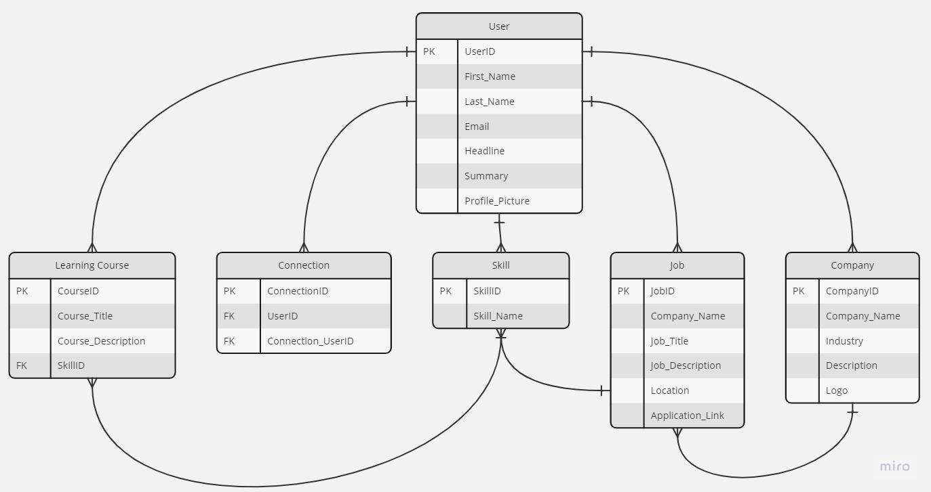

**Significance of the ER Diagram:**

LinkedIn's ER diagram provides a comprehensive overview of how the platform manages user profiles, content sharing, interactions, and networking. It highlights the interdependencies between entities and clarifies the relationships that enable users to build their professional networks, share knowledge, and engage in meaningful discussions.

Understanding this ER diagram is crucial for developers, data analysts, and platform administrators as it guides the design and maintenance of LinkedIn's database. It ensures the efficient handling of user-generated content, interactions, and connections, contributing to the platform's success in the realm of professional networking.

**Conclusion:**

In this case study, we explored the design of LinkedIn's schema and Entity-Relationship diagram. LinkedIn has redefined professional networking and career development by effectively addressing real-world challenges pfaced by professionals. The platform's complex data model, consisting of entities like users, connections, jobs, skills, and learning courses, serves as the foundation for its seamless functionality. By understanding this schema, we gain insight into how LinkedIn facilitates professional growth, networking, and skill development, making it a vital tool for individuals and businesses in the professional world.